$$f:x→2x$$  Domain: $x∈R, 0≤x≤8$ | 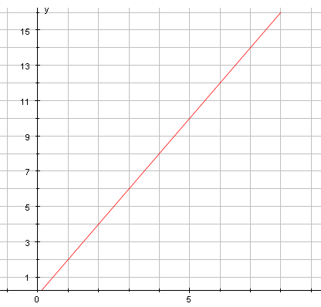 | Range: $y∈R, 0≤y≤16$
$$f:x→x^{2}+1$$  Domain:$x∈R$ | 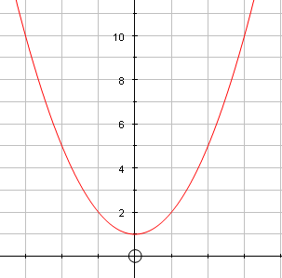 | Range:$y∈R, y≥1$
$$f:x→3x-1$$  Domain: $x∈R, -2<x<2$ | 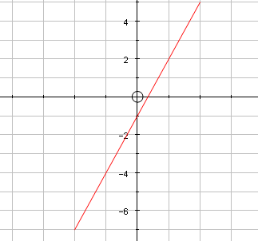 | Range:$y∈R, -7<y<5$
$$f:x→\frac{1}{x}$$  Domain:$x∈R, x≠0$ | 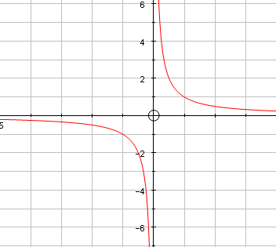 | Range:$y∈R, y≠0$
$$f:x→2x^{3}$$  Domain:$x∈R, -1≤x≤4$ | 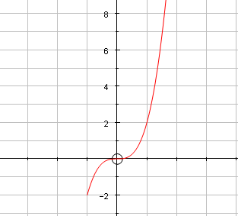 | Range:$y∈R, -2≤y≤128$
$$f:x→\frac{1}{{\left(1+x\right)}^{2}}$$  Domain: $x∈R, x≠-1$ | 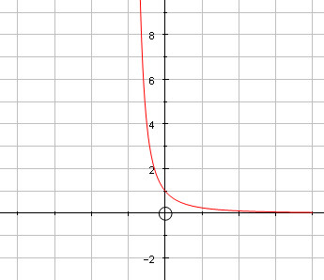 | Range: $y∈R^{+}$

